This document will have three parts; Downloading and installing Android Studio, setting up Android Studio for FTC, and downloading and installing the FTC SDK (Standard Development Kit).

Downloading and Installing Android Studio

- Go to this link: https://developer.android.com/studio
- If you’re using Windows, click on the “Download Android Studio”.
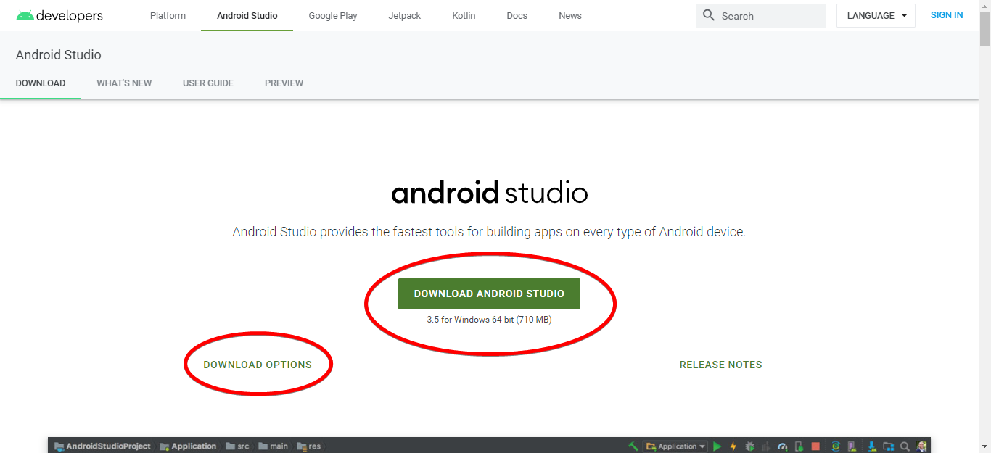
  - If you’re using Mac/Linux, click on “Download Options”. It will bring you to the bottom of the page where you can select the appropriate version to download.
- Once you click “download”, a new window will pop up with the End User License Agreement. Check the box to agree and then click “download”. Select where you want to save it, click OK, and Android Studio will start downloading.
  - NOTE: downloading will take a while, even if you have a good internet connection
- Once it is finished, go to the folder where you saved it to and run the installer.
- Follow the installer’s instructions to finish installing Android Studio (just click Next -> Next -> Next, but if you're short on disk space, you can uncheck the "Android Virtual Device" option on the "Choose Components" page).

Downloading the FTC SDK
Before we can set up Android Studio, we’re going to need to download the FTC SDK necessary to code and download to the robots. Follow the steps below to download:
- Go to this link: https://github.com/FIRST-Tech-Challenge/SkyStone
- Click on “Clone or Download” and then click on “Download ZIP” from the dropdown. Select where you want to save it, click OK, and the FTC SDK will start downloading.
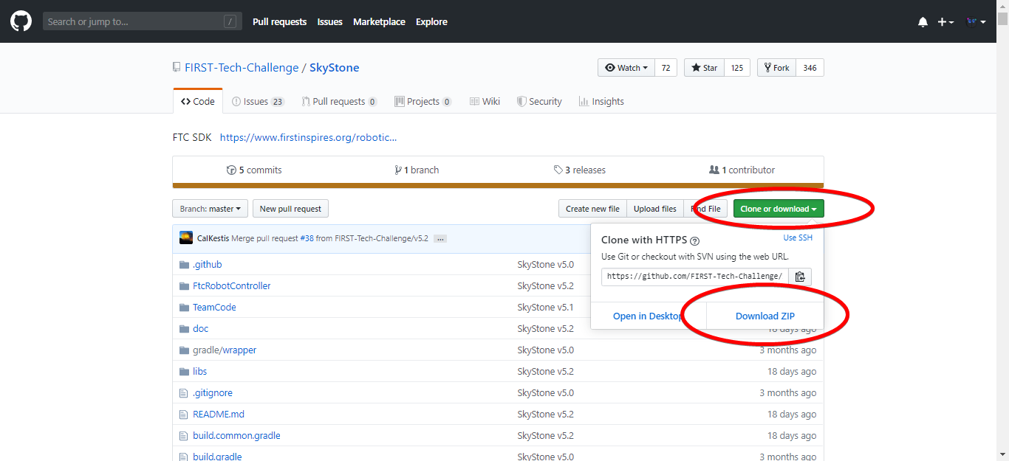

Setting Up Android Studio

- Run Android Studio (the last panel of the installation may have started Android Studio for you). The first time you run Android Studio, it will prompt for some configuration options, but the default settings do not need to be changed.
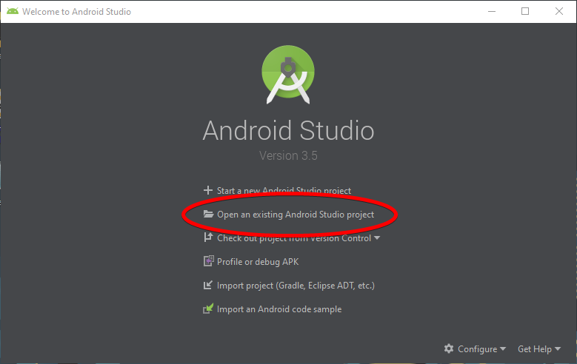
- At the "Welcome to Android Studio" screen, choose “Open an existing Android Studio Project”.
- Wait for Android Studio to finish setting up the SDK, and you should get a menu like this
- Below is the Android Studio workspace when everything is working. However, more likely than not, the console will show error messages about not having the most up-to-date tools to run the SDK.
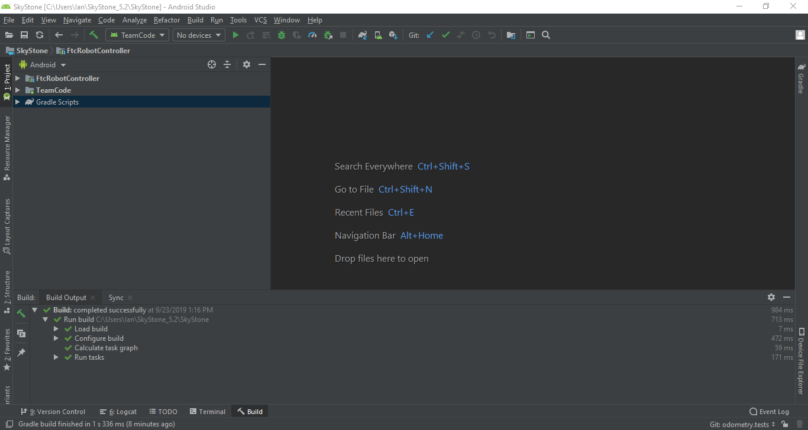
  - These messages take you straight to where you need to be to update the tools, so there shouldn’t be too much confusion.
- Expand the FtcRobotController node, then browse to the java - com.qualcomm.ftcrobotcontroller - opmodes folder. This has the sample opmodes you can try out if you have a robot built.
- To create your own program, go into TeamCode -> java and right-click on “org.firstinspires.ftc.teamcode”. Select New -> Java Class. Then name your file, and you’re ready to program! (if the Java Class option isn’t there, you may need to open one of the sample programs first. Just double click one to open)

